***TASK 1***

**Task: Create a simple Java application that simulates a basic calculator. The calculator**

**should be able to perform addition, subtraction, multiplication, and division operations based**

**on user input.**

***Program:***

import java.util.Scanner;

public class SimpleCalculator {

public static void main(String[] args) {

Scanner reader = new Scanner(System.in);

String continueInput = "yes";

while (continueInput.equalsIgnoreCase("yes")) {

System.out.println("Enter first number:");

double num1 = reader.nextDouble();

System.out.println("Enter an operator (+, -, *, /):");

String operator = reader.next();

if (operator.length() != 1)

{

System.out.println("Error! Invalid operator input. Please enter only one operator (+, -, *, /).");

reader.next();

}

System.out.println("Enter second number:");

double num2 = reader.nextDouble();

double result;

char operatorInput = operator.charAt(0);

switch (operatorInput) {

case '+':

result = num1 + num2;

break;

case '-':

result = num1 - num2;

break;

case '*':

result = num1 * num2;

break;

case '/':

if (num2 != 0) {

result = num1 / num2;

}

else {

System.out.println("Error! Division by zero is not allowed.");

return;

}

break;

default:

System.out.println("Invalid operator! Please use +, -, *, or /.");

return;

}

System.out.println("The result is: " + result);

System.out.print("Do you want to continue? (yes/no): ");

continueInput = reader.next();

}

}

}

Output:

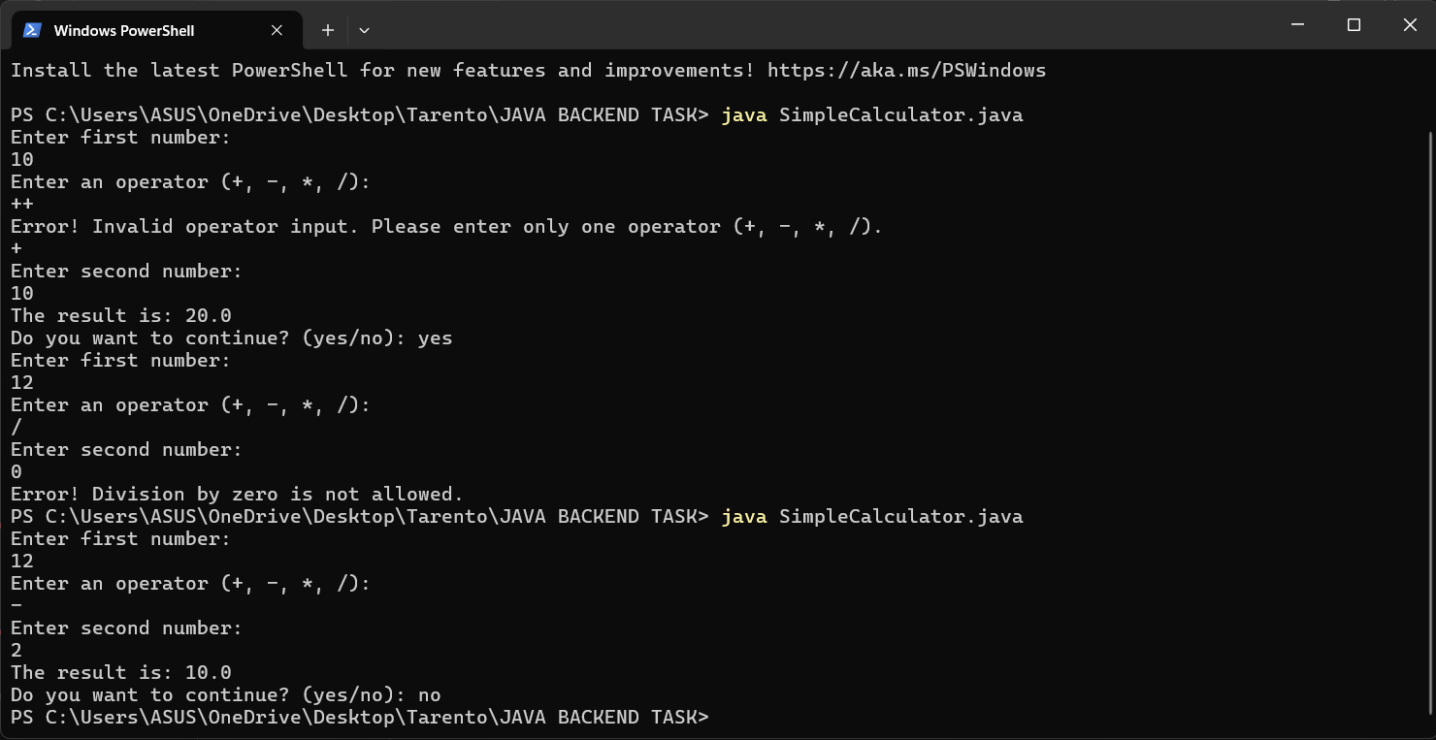

***TASK 2:***

**Task: Create a Java program that calculates the grade based on marks entered by the user.**

***Program:***

import java.util.Scanner;

public class GradeCalculator {

public static void main(String[] args) {

Scanner scanner = new Scanner(System.in);

String continueInput = "yes";

while (continueInput.equalsIgnoreCase("yes")) {

System.out.print("Enter marks obtained (out of 100): ");

int marks = scanner.nextInt();

char grade = calculateGrade(marks);

System.out.println("Grade: " + grade);

System.out.print("Do you want to continue? (yes/no): ");

continueInput = scanner.next();

}

scanner.close();

System.out.println("Thank You!");

}

public static char calculateGrade(int marks) {

if (marks >= 90) {

return 'A';

} else if (marks >= 80) {

return 'B';

} else if (marks >= 70) {

return 'C';

} else if (marks >= 60) {

return 'D';

} else {

return 'F';

}

}

}

***Output:***

